8 Nutrients

What are the causes, effects and impacts of changes in nutrient cycles, and why are they vital?

Leaflet Human Alteration of the Global Nitrogen Cycle: Causes and Consequences
http://www.esa.org/science_resources/issues/FileEnglish/issue1.pdf

Nutrient Cycles

Left alone, natural systems keep nitrogen, carbon, and other key ingredients of life balanced. We’ve thrown natural cycles out of balance. Left alone, natural systems maintain cycles that keep these elements circulating where they’re needed and in the right amounts. In order to have the clean water, healthy ecosystems, and stable climate we need to survive, we’ll have to stop overloading the systems.
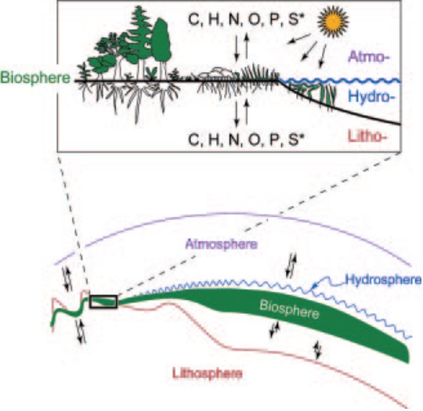

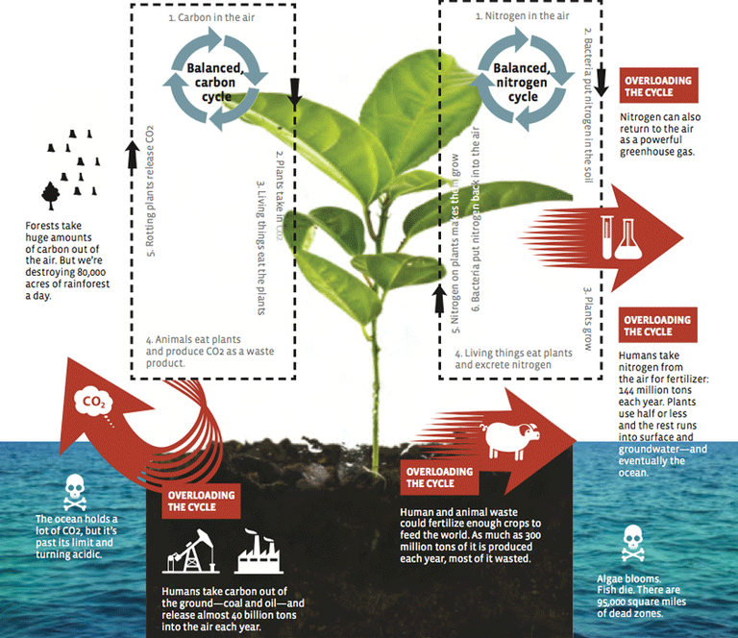

Carbon cycle

We've put carbon, from burning coal and oil, into the air. Excess carbon is heating the planet.
Carbon is essential to life: 18 percent of a human body and 50 percent of a tree is carbon.

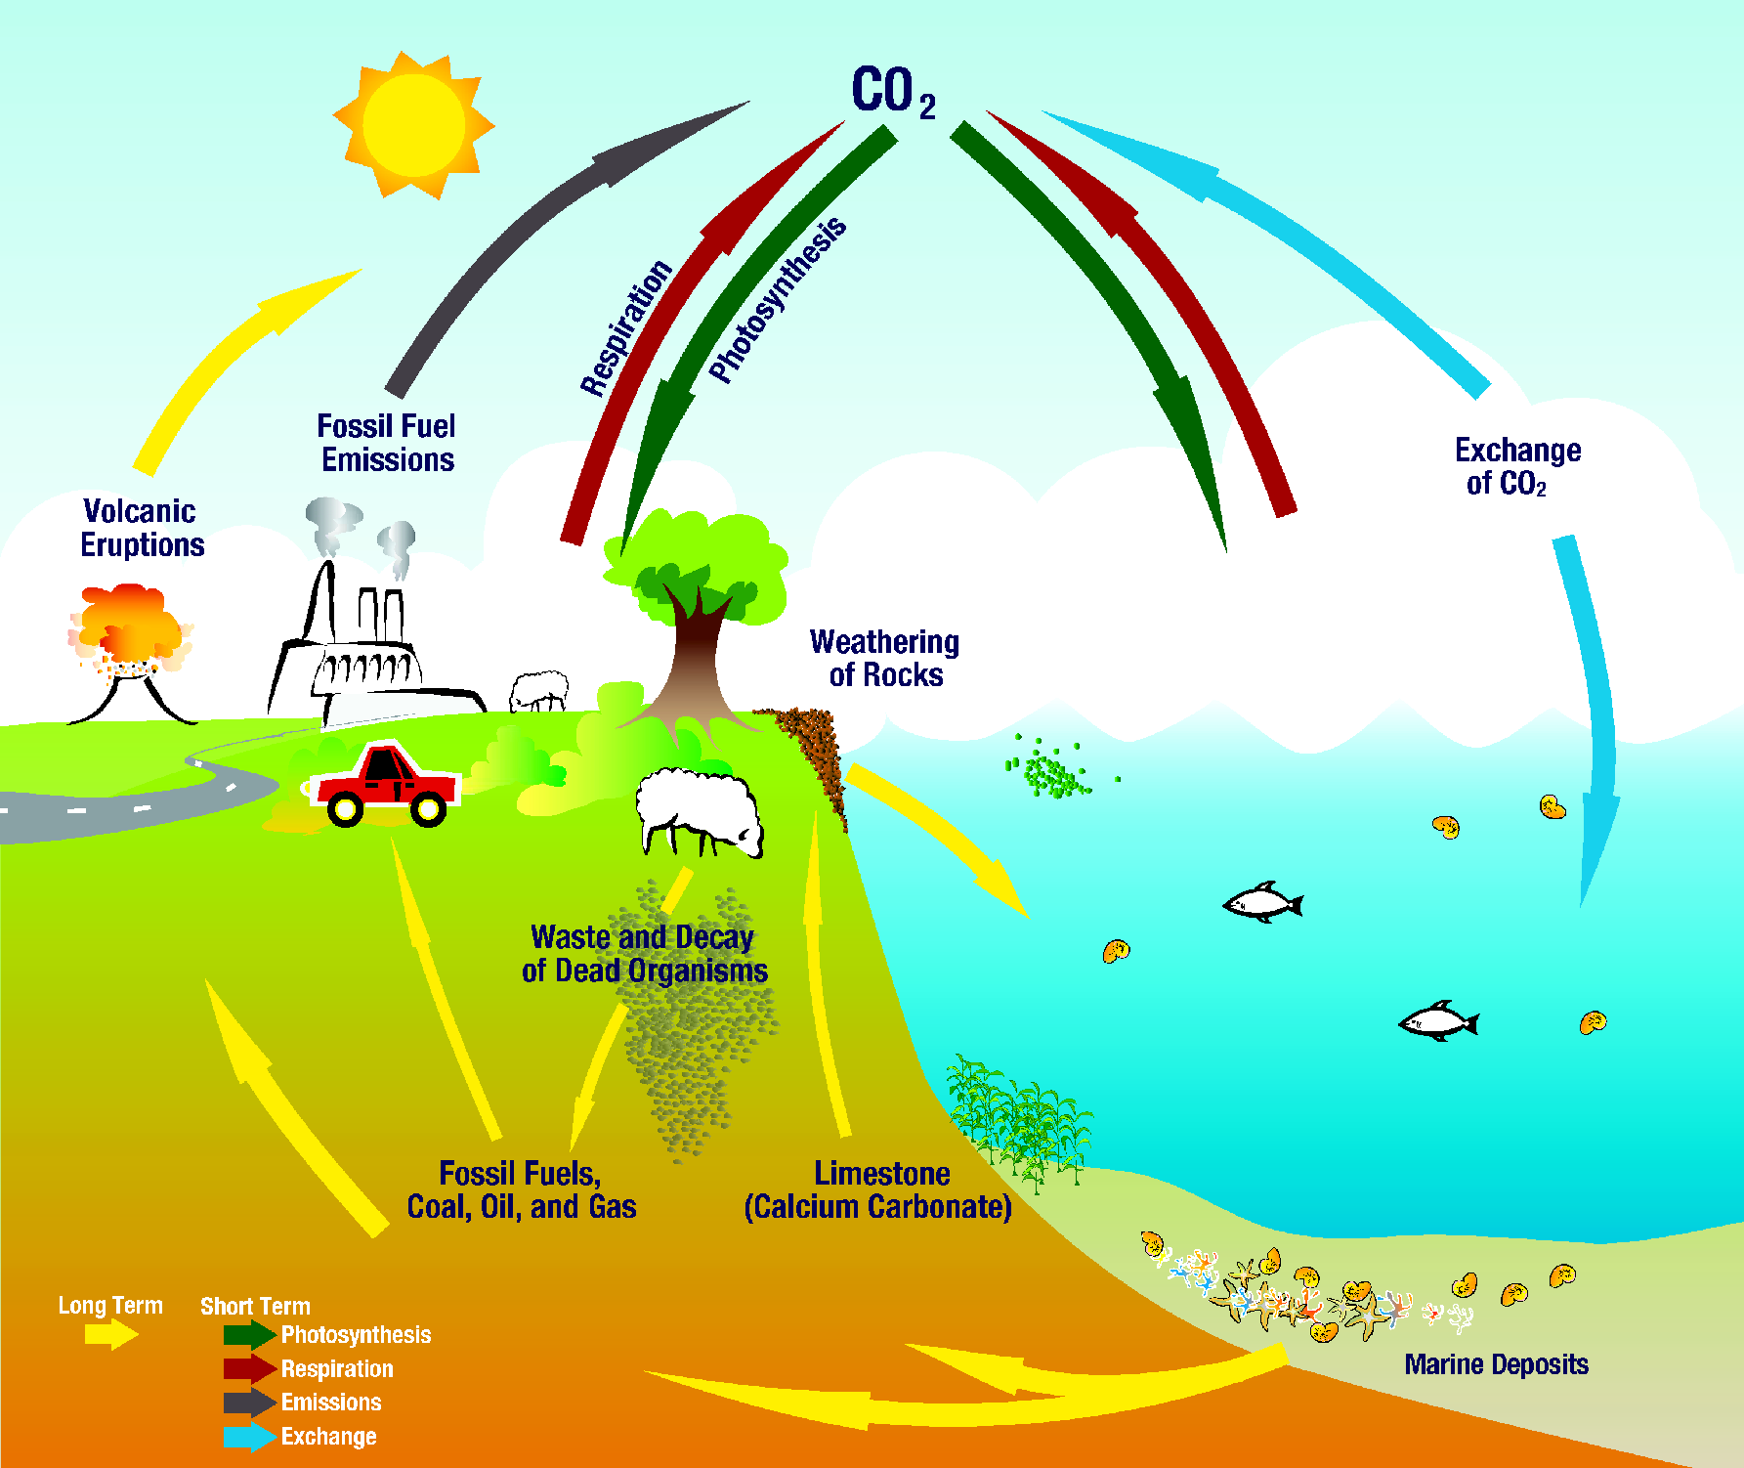

Nitrogen cycle

Nitrogen is the most common element in the atmosphere. Plants can’t grow without it. But we’ve pulled nitrogen out of the air to feed plants with artificial fertilisers. Excess nitrogen from these fertilisers is polluting the air and water.

- Humans capture nitrogen from the air and produce 131 million tonnes of nitrogen fertilizer each year globally. This adds more nitrogen to the planet than ecosystems would use under natural conditions, busting the Earth's nitrogen budget.
- Excess nitrogen runs into surface and groundwater. There are now more than 95,000 square miles of dead zones in coastal waters, largely caused by nitrogen pollution.
- Both fossil-fuel burning and agriculture also send nitrogen pollution into the air—as Nitrous oxide (N2O), another powerful greenhouse gas, and Nitric oxide (NO), a precursor to smog and acid rain.
- If we recycled waste (both animal manure and human waste) and used it as fertilizer, we could feed the world with the nitrogen nature produces. If we converted to renewable energy and organic agriculture, we could stop polluting the planet with excess nitrogen.

Most of the human activities responsible for the increase in global nitrogen are local in scale, from the production and use of nitrogen fertilizers to the burning of fossil fuels in automobiles, power generation plants, and industries. However, human activities have not only increased the supply but enhanced the global movement of various forms of nitrogen through air and water. Because of this increased mobility, excess nitrogen from human activities has serious and long-term environmental consequences for large regions of the Earth.
The impacts of human domination of the nitrogen cycle that are identified with some certainty include:
- Increased global concentrations of nitrous oxide (N2O), a potent greenhouse gas, in the atmosphere as
- well as increased regional concentrations of other oxides of nitrogen (including nitric oxide, NO) that
- drive the formation of photochemical smog;
- Losses of soil nutrients such as calcium and potassium that are essential for long-term soil fertility;
- Substantial acidification of soils and of the waters of streams and lakes in several regions;
- Greatly increased transport of nitrogen by rivers into estuaries and coastal waters where it is a major
- pollutant.
- Accelerated losses of biological diversity, especially among plants adapted to low-nitrogen soils, and subsequently, the animals and microbes that depend on these plants.
- Caused changes in the plant and animal life and ecological processes of estuarine and inshore ecosystems, and contributed to long-term declines in coastal marine fisheries.



